
OBC Update
Thursday 25 July 2025
Hi Everyone
Big congratulations to the Otaki Club Rep Team who played Saturday 12th July in the Wellington Regional Championships. Coming 2nd= with Waikanae was terrific. Wellington came first. Our team was Cheryl, Basia, Rob, Bridget, Helen F, Rachel, Steve, Terri, Clare, Lynne T-C.


Thanks everyone for making the Mid-Winter Social a very successful afternoon – mulled wine, cheerios and fun …. What more could a body ask for?

Our next event will be our Intermediate 5B and Junior 3B Tournament on Sunday 24th August, sponsored by JMI Wealth.

Message from Basia about the Swiss pairs event that begins next Tuesday evening: Hi all
Here is the final list for the Swiss pairs which are being played on the next 3 Tuesday nights. We have 7 tables. A reminder that you will need to arrange your own substitutes if you are unable to play. The confirmed pairs are:
Bridget and Paul; Pip and Royce; Rachel and Roger; Emily and Oscar (Emily's brother is subbing on the first night); Rob Hunter and Robyn R; Cheryl and Liz; Anne and Tim; Bryan and Ginny; Graeme and Moira; Barbara and Karen Pugh; Carolyn and Clare; Faith and Andrew; Basia and Dorothy; Robyn M and Pat Whittle.
A special thank you to Pat and Robyn for stepping in to make up a full table, and to Tim for directing and Graeme for scoring.
Alastair is available as a fill-in. (He asks the more notice, the better.)

_

On Monday 30 June the Monday players had afternoon tea at the end of play, to celebrate
halfway through the year. Vera came up with some fun prizes – thank you Vera .
*****
NZB Ranking Report in the top 20: Bridget – Life Master 20th. Basia – Provincial Master 18th=. Certificates of Proficiency – Steve 8th, Julie 10th and Terri 13th.

From the Committee:
- NZ Bridge may have just about sorted the issue of disappearing B points ...
- Rachel has deleted a lot of old email – good progress..
- Financial: Mark is reviewing the insurance – important job every year.

- The rooms were hired out for 2 extra events. Worked well.
- We have sponsorship for $400 for our new Swiss Open Tournament 19th October from Kelly and Co. Thank you.
- And thanks Graham E for waterblasting the path.

*****
LESSONS - Claudia’s lessons have moved to playing hands on Wed nights at 7pm. Anyone is welcome if you’d like relaxed evening to play and discuss a few hands. We are also welcoming a few of the Paraparaumu learners to practise.
Learner players are coming through to play on Mondays and/or Thursdays.
Claudia asks: Please do not double them. If you have a different system please explain without being asked. If needs be we can put a sticker on their name badges. If you feel their play or bidding needs positive advice please ask them first if they would like it. Only a few players feel confident to come through; please don't put them off.

A teacher for 2026 lessons. If anyone would like to be the teacher, Claudia says a change would probably be good. She will do it if no-one else offers.
There is a Teachers' Conference 18th and 19th October in Wellington. Registrations have begun.
Our new members: Lynne Tolley-Cowan 60122, Stewart Fraser 59567, Chris Harrington 59613, Debra Harrington 59568, Robyn Karl 59617, Jennifer Sims 59677, David Walshaw
30072. *****
Online supported play for learners began June 8th, and continues Sundays 4pm for 2 hours.
$5/session. For first and second year players. RealBridge

*******

NZ Bridge ONLINE INTERMEDIATE LESSONS START AUGUST
The NZB Teaching and Learning Committee has organised online Intermediate lesson –
suitable for those who have played a few years.
Cost: $20 for set of 3 lessons or $8 single lesson
Where: Pay through HelloClub and you will receive the RealBridge link
Time: Lessons are 4-6pm Sundays, repeated 7-9pm the following Tuesdays. Log on at least 15 minutes early, check your camera and microphone, as you will be playing the practice hands.

Schedule:
August Sunday 10 1. Escaping 1NT Doubled Tuesday 12 “ “ “

Sunday 17 2. Interference over our 1NT Tuesday 19 “ “ “
Sunday 24 3. Competing over their 1NT Tuesday 26 “ “ “

Further Lessons: Sept/October will be notified soon.

TOURNAMENTS

Levin 5A OPEN tournament Sunday 30th July $40
Cambridge Sixes – 9th August, Lake Karapiro. Enter a team of six – 2 Open, 2 Intermediate , 2 Junior. $50pp. Contact for extra players..
North Island Pairs 2nd/3rd August. 9.30 Real Bridge link at www.nzbridge.co.nz Enquiries to Bridget bridget@nzbridge.co.nz Closes Wed 30th July. $48. NEW ACCOUNT NUMBER 02 0466 0268199 004
Kapi-Mana Intermediate August 10th. Hutt Intermediate Saturday 30 August. Kairangi Multigrade 31st August.
Victoria BC, Wellington - Intermediate and Junior Sunday 14th September.
Karori Open Swiss pairs 5A. 24th August
Wellington 6’s. 7th Sept. 3B Junior, 5B Intermediate, 3A Open Swiss pairs. Dress up team colours! Lunch provided. 9.30am. Limited to 16 teams. $40

Online:
East Coast Bays, Sunday 3 August North Harbour Autumn Pairs 7pm and Wed 6 August - Realbridge August Pairs 7pm. 7 sessions, 24 boards.
Go to www.ecbbridgeclub.co.nz Click on RealBridge link then Session link. Opens 6.40pm. $5 per session or $35 for all. Pay ECB Bridge Club 38 9015 0784953 00. Particulars: Your name, Details: RealBridge, Reference: Your NZ bridge number. Once you have entered please email colin-bray@xtra.co.nz and advise your name, club and partners name so you can receive our newsletter.

_

From the Chair – Alan @ NZ Bridge:
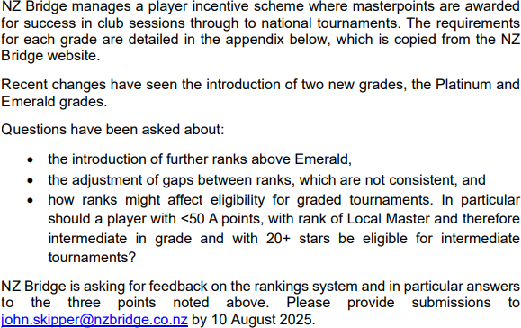
- Consultation document is out on an award system to motivate players. Please see full document if you wish to comment.
- Regional committees will cover marketing costs for lessons.
- Tournament review - to give more flexibility to regions.
- Retaining members can be challenging. A Retention of Members document is attached and has been printed off – it’s well-worth reading. Only 50% of learners stay. Couples, friends, siblings stay longer. NZ membership has risen but not back to Dec 2023 level. They suggest “Ensure beginners have more time learning before we feed them to the sharks in the main room”! Lots more.
- Review of lesson material is being tested - learners get to play hands a lot sooner.
- A Fair Play committee is established (previously Complaints).
- Bridget is reaffirmed as Chair of Events.
- NZ Bridge Toolbox has 80 items for club help.
- Encouraging new Directors – idea is accreditation rather than exams. Develop an app as a simple tool for Directors.
- You can register at NZ Bridge for their email communications.
NZ Bridge AGM minutes – Budget for this year is being reworked to try to achieve break- even. Board members asked for a 5 year forecast to be completed. Anne Barraclough and Alan Morris will retire from the Board, both having completed 3x3 year terms.

Loveblock Pairs this year – Friday October 17th. Extra funds go to support Youth Bridge in NZ. Recommended play is at no more than intermediate level. Please support Loveblock Wines – a Marlborough organic wine producer. $10.

🎉 Register Now for NZ Bridge Congress 2025 Nov 8-15th

♠️ 8 days. 100s of players. 1 unforgettable experience.

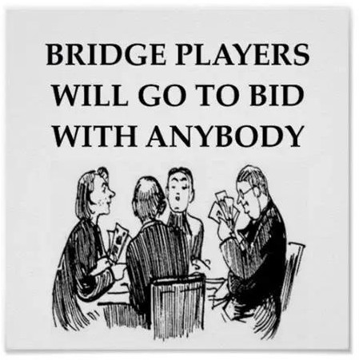
Unexpected NZ Bridge comment became a world-wide social media success:
“Bridge is the new Tinder”.

Happy bridge everyone. Pip Martin President 021 2972144

